THE TEMESCAL

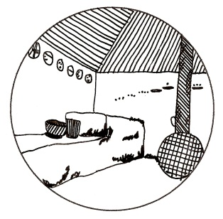

THEMES
- Effects of natural disasters
- Erosion

VOCABULARY
Students should be familiar with the following terms:
Hurricane: a violent storm; usually comes from the water

SUGGESTED DISCUSSION QUESTIONS
Students may discuss the following in small groups and report to the class:
- What does Elena’s father say when Elena asks why people go to meetings to talk about what everyone knows? Can you think of an example of this in your life?
- What are direct and indirect causes of death from hurricanes?

RECOMMENDED ACTIVITIES
Additional relevant activities are under the subject guides.
- Pros and cons: Pretend you are Elena’s parents at the beginning of the story. Make a list of pros and cons about leaving the village versus staying.
- Erosion mountain: Simulate erosion. Stack a few books and place one of a board on it to create a slope. Fill a lasagna pan with soil and put on the board. Use a watering can to pour water on the soil. Observe. For a variation, put items on the soil. What happens to them?

