SALTY TEARS AND THE RISING SEA

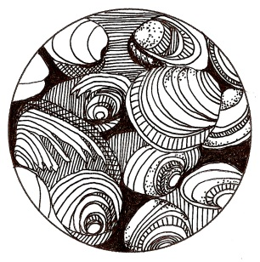

THEMES
- Rising sea levels
- Impacts of climate change
- Coastal life

VOCABULARY
Students should be familiar with the following terms:
Borehole: a deep hole drilled into the earth to get clean drinking water
Erosion: the movement of soil by water, air, or man-made means
Shellfish: ocean creatures that live in shells, such as clams and oysters

SUGGESTED DISCUSSION QUESTIONS
Students may discuss the following in small groups and report to the class:
- Where does Phuong’s family get their food?
- How does the rising sea level affect Phuong’s family?
- Explain why Phuong’s uncle had to go to the city. How did this affect his life?

RECOMMENDED ACTIVITIES
Additional relevant activities are under the subject guides.
- Beach tour: Take a tour of tidepools or a beach. What edibile foods can you find?
- Beach erosion: Pack sand into a basin. Add water. Observe. Add more. Observe the effects on the packed sand as more water is added.

