FEEDING OUR LAND, FEEDING OUR FAMILY

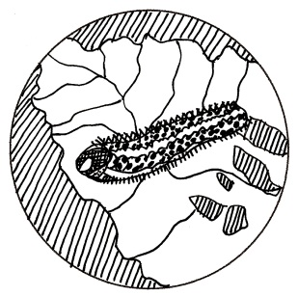

THEMES
- Pesticides
- Indirect effects of human activities
- Organic farming
- Family
- Sacrifices
VOCABULARY
Students should be familiar with the following terms:
Pesticides: chemicals made to destroy plants, weeds or fungus that may interfere with the growth of crops

SUGGESTED DISCUSSION QUESTIONS

Students may discuss the following in small groups and report to the class:
- How do Lidia’s family members feel about the use of chemicals on the farm?
- How do the Guatemalan farms compare to the American farms? Do they grow different things? Do they look the same? (e.g., Are they the same size or organized the same way?)
- What does Abuelita say about how farms have changed? What brought on these changes?
- What are the differences between organic or ‘ecological’ farming and using pesticides? If you were a farmer, what would you choose?
- How does Mynor’s illness change his father’s mind? Why do you think that is?

RECOMMENDED ACTIVITIES

Additional relevant activities are under the subject guides.
- Grocery store map: have students go to a grocery store and draw a map of the inside of the store. Where are the vegetables? Where is the meat? Where are the processed foods? Students should then share their maps at school and discuss their findings. Students should create a pie chart showing the estimated percentage of the store made up of fruits/vegetables, dairy, meat, or processed foods.
- Recipes finder: have students explore different recipes in class and look at ways to add more fruits and vegetables to the meal. Students may also look at turning a nonorganic meal into an organic one. How much more would it cost? Students could also bring in organic, healthy foods to show to other students…and to eat as well!
- Food production in the media: students should research different ways in which the food and farming movement is portrayed in the media. Have students pick one article, movie, or show and write up a summary of the way food is used. Examples to reference: Jamie Oliver’s Food Revolution (TV show), Food Inc. (movie), Fast Food Nation (book or documentary), or articles by Michael Pollan (food critic and analyst).
- Food fight: have students create posters on which they paste cut-out pictures of healthy (good) and nonhealthy (bad) foods. They can present these posters to the class and teach their classmates about the health benefits of the good foods and the negative impacts of the bad foods.

